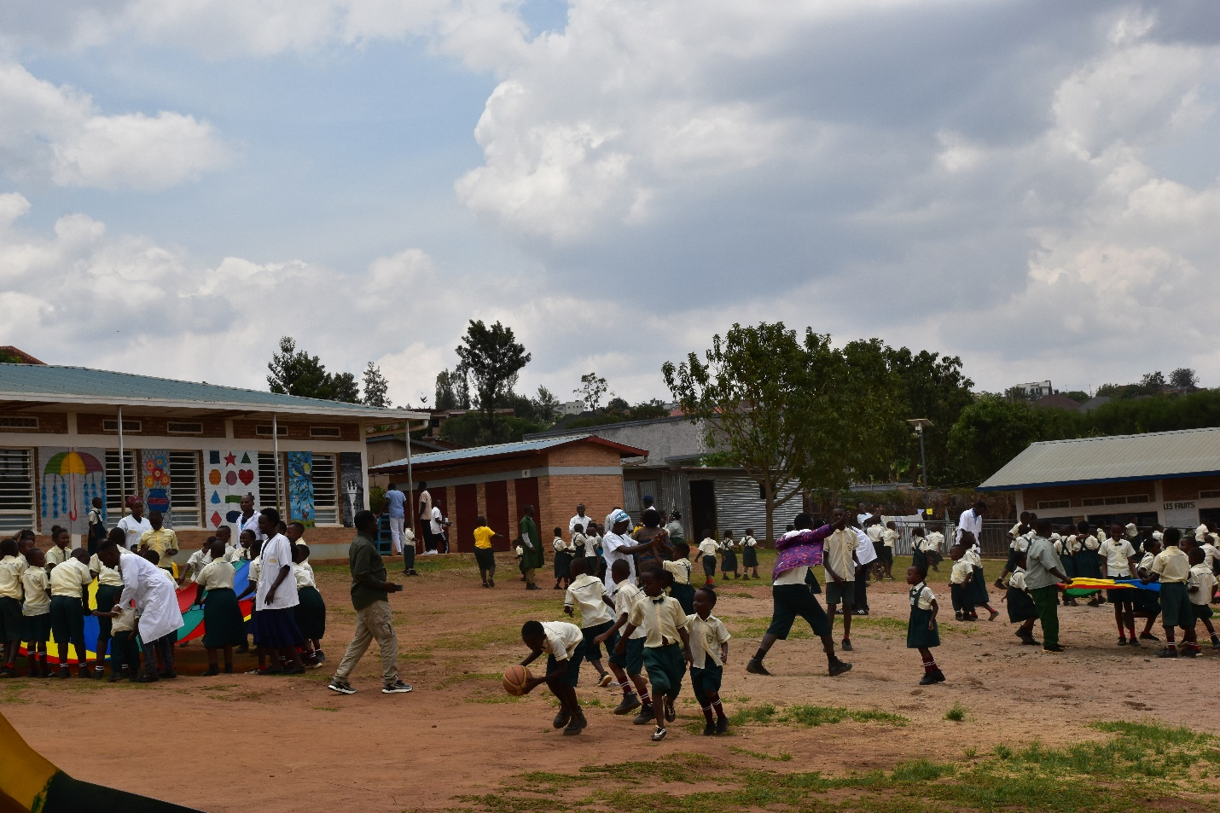
MISSION: To provide quality inclusive education and holistic support that enables every child to learn, develop, fully participate and thrive.
VISION: A school where every child, regardless of ability, is included, empowered to learn, play, and thrive to their full potential, and where inclusion is the norm, not the exception
SCHOOL MOTTO: “Every Child Matters, Every Child Can Learn, Every Child Can Thrive.”
Izere Mubyeyi School (IMS) Izere Mubyeyi Inclusive School is an educational institution in Rwanda that aims to provide learning opportunities for children with different abilities and needs. It promotes inclusive education, where children, including those with intellectual disabilities, can learn together in a supportive and respectful environment. Its goal is to help every child develop their knowledge, skills, confidence, and potential.
The school also provides specialized teaching, therapy, and practical skills training to help children become more independent and participate fully in society. It has been founded by Izere Mubyeyi organization in 2017.
Currently, the school has more than 170 students and more than 22 staff. The school follow national program and curriculum for children with special needs education. The school welcome national and international volunteers, internees or visitors who would like to impact future generation. For more information, you can contact directly the school via email: izeremubyeyi1centre@gmail.com or phone number (+25)0785319850 the school director.

Integrated Educational Approach at Izere Mubyeyi
- Identification and Assessment
Children are assessed to understand their educational, developmental, physical, emotional, communication, and social needs. The assessment results guide appropriate interventions.
- Inclusive Education
Children with disabilities and other learning needs are given opportunities to learn in a supportive environment alongside their peers, according to their abilities and needs.
- Special Needs Education
Individualized support is provided to children who need additional assistance, including adapted teaching methods, learning materials, and individualized learning plans.
- Early Childhood Education
The school provides early identification and early intervention for children with developmental and learning difficulties to support their development from an early age.
- Individualized Teaching and Learning
Teachers adapt lessons, activities, assessments, and learning materials according to each child's abilities, strengths, challenges, and learning pace.
- Health and Rehabilitation Services
Education is integrated with services such as physiotherapy, functional support, and other rehabilitation interventions where needed. This helps children improve their physical functioning and participation in learning.
- Family and Parent Involvement
Parents and caregivers are involved in planning, supporting learning at home, monitoring progress, and making decisions concerning their children's education.
- Multidisciplinary Teamwork
Teachers, school leaders, rehabilitation professionals, parents, and other specialists work together to address the different needs of each child.
- Social and Life Skills Development
In addition to academic learning, youth are supported to develop simple vocation skills, self-care, social interaction, independence, confidence, and practical life skills.
- Community Participation and Awareness
Izere Mubyeyi works with families, community leaders, organizations, and other stakeholders to promote acceptance, inclusion, and the rights of children with disabilities.
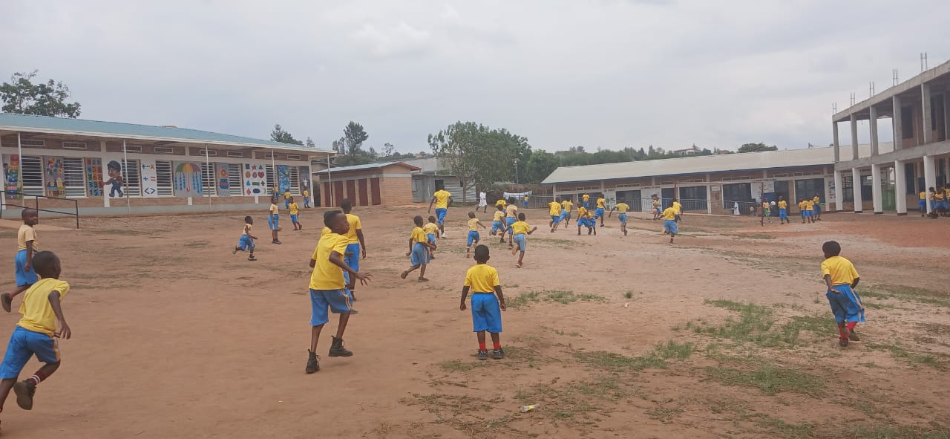
1. Why am I participating in the RISE project?

I am participating in the RISE Project because I want to improve my knowledge and skills in Special Needs and Inclusive Education. The project provides valuable training and practical knowledge that can help me better support children with disabilities and other learners with special educational needs.
I am also participating because I want to share the knowledge and skills gained from the project with other teachers, school staff, parents, and the wider community. In this way, I can contribute to improving inclusive education and the well-being of children with intellectual disabilities in Rwanda.
Francis NTIHINYUKA, RISE-Kwigira Board member

2. How have you benefited from it so far?
“So far, I have benefited greatly from participating in the RISE Project. The training has improved my knowledge and understanding of Special Needs and Inclusive Education, particularly how to identify and respond to the different needs of children with intellectual disabilities.
I have gained practical skills in supporting learners with different abilities, adapting teaching and learning approaches, promoting participation, and creating a more inclusive and supportive classroom environment.
The project has increased my confidence in my role and has given me new ideas that I apply at Izere Mubyeyi School. I am also able to share the knowledge and skills gained with other teachers and staff, contributing to better educational services for children with disabilities.”

Francis NTIHINYUKA, Izere Mubyeyi School Director

