HOME BASIC EDUCATION
MISSION | To provide quality, inclusive and child-centered education that helps every child belong, learn and grow.
VISION | A future where every child has access to inclusive, quality education and the opportunity to reach their full potential.
MOTTO | Belong. Learn. Grow.
About HOBE
HOME BASIC EDUCATION (HOBE) is a private early childhood education school in Rwanda, founded by Akingeneye Esperance.
HOBE began in 2009 as a volunteer initiative to support children in the community who had limited access to education. The founder started by teaching 25 children from her living room, guided by the belief that every child deserves an opportunity to learn in a safe, caring and supportive environment.
Over the years, this community initiative developed into a formal early childhood education school. HOBE was formally registered in 2017 and currently operates through two accredited ECD branches: one providing Home-Based ECD services and the other providing Community-Based ECD services. HOBE uses a child-centered, play-based and Learning by Doing approach, while working closely with families and the community to support children's holistic development.
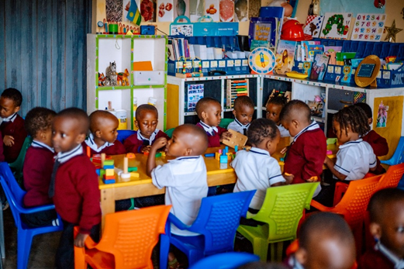
Children at HOBE participating in hand-on learning activities

Special Needs & Inclusive Education
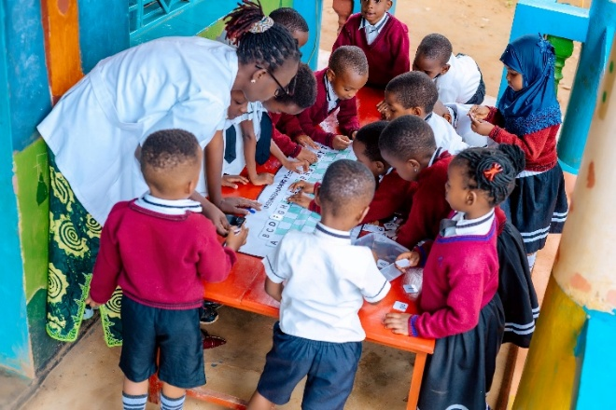
A teacher guiding children through a collaborative learning activities
HOBE is committed to strengthening Special Needs and Inclusive Education (SNIE) within its educational practice. The school recognizes that children have different abilities, strengths and learning needs.
Through its engagement with RISE-KWIGIRA, HOBE is strengthening its teachers' knowledge and practical skills to better understand individual learning needs, adapt teaching and learning activities, and promote meaningful participation for all children.
“Inclusion is not simply about having a child in the classroom; it is about ensuring that the child is seen, supported, able to participate and given a real opportunity to learn.”
HOBE and RISE-KWIGIRA
HOBE's participation in RISE-KWIGIRA provides an opportunity to strengthen teacher capacity and improve practical approaches to Special Needs and Inclusive Education. Through the project, HOBE continues to reflect on its teaching practices and explore more responsive ways of supporting children with different learning needs.
Since its beginning, HOBE has supported more than 600 children through its education and learning activities. The school continues to focus on strengthening the quality of its existing branches, teacher capacity and inclusive educational practices.
Founder's Perspective
“I started this journey through volunteerism because I wanted to help children in my community who had limited access to education. Today, my commitment remains the same: to make education more inclusive and to ensure that every child has an opportunity to belong, learn and grow.”
Akingeneye Esperance
Founder & Director, HOME BASIC EDUCATION
Safeguarding Note: All photo of children in this profile are with permission from their parents or guardians, following child protection standards.

