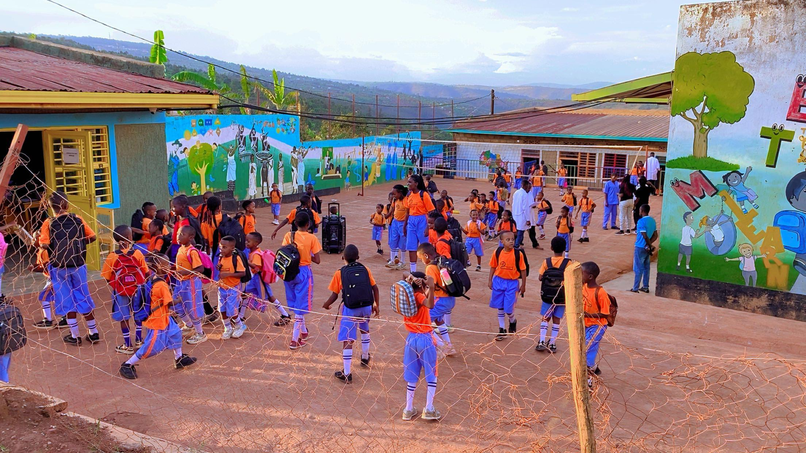MISSION: “Educate children to achieve their bright future”
BRIGHT HORIZON SCHOOL (BHS)
VISION: “All children have access to quality education”
SCHOOL MOTTO: Education As Foundation
Bright Horizon School (BHS) is a private primary and nursery school located in East Africa, in the country of Rwanda. It has been founded in 2020 by it founder Isaie MIHIGO in order to support the children from vulnerable families have access to quality education in their nearby community. Currently, the school has more than 200 students and more than 10 educators. The school follow national program and its use English as teaching languages. The school has developed its own integrated teaching approach. The school can host national and international volunteers, internees or visitors who would like to impact future generation. For more information, you can contact directly the school via email: brighthorizonschool509@gmail.com or phone number (+25)0788210502.
Integrated Educational Approach(IEA) based on Four Pillars:
- Individual Child Focused Education (ICFE),
- Creative Art Drive Education (CADE)
- School-Parents Interaction Education (SPIE)
- Parental Educational Session (PES)
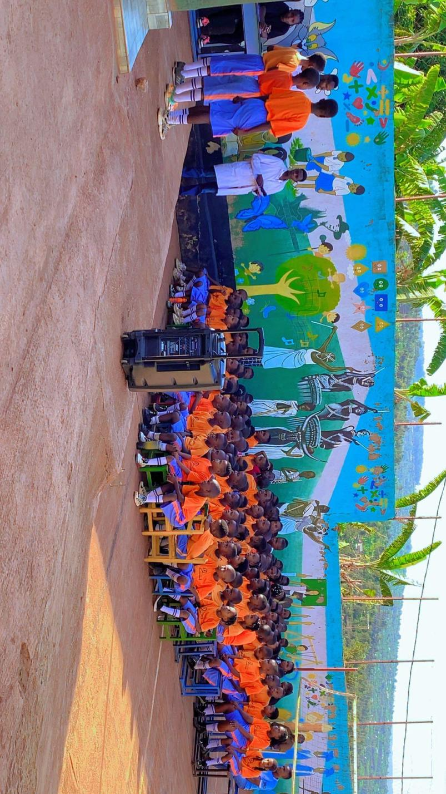
BRIGHT HORIZON SCHOOL(BHS)

